TECHNICAL FACT SHEET BEHIND THE TIMBER FACADE AT THE RIDGE

Driving down Dock Road in the direction of the Watershed complex in the V&A Waterfront, one cannot help notice the impressive and completely unique timber pleated façade warmly cladding the Waterfront’s newest building which is currently under construction. However, there is a lot more to this feature than aesthetics.

Incorporating cross-laminated timber (CLT), in addition to energy efficient design principles, the Ridge’s new façade speaks to the sustainability ethos of the V&A Waterfront’s development vision and is expressed in what will become one of Cape Town’s greenest office buildings.

Here’s all you need to know about the V&A’s newest design innovation.

Background
It is a well-known fact that the operations of buildings and the urban environment have placed a heavy toll on our planet, contributing at least 28% to modern day global greenhouse gas emissions (GHGE) compared with all the other factors. (source: Green Building Council of South Africa) This is leading to climate change, which threatens the lives and livelihoods of billions of people on the planet.

Such an issue demands that mitigation strategies be implemented without delay. It places pressure on the entire built environment value chain to ‘come to the party’ and also line up with various global sustainability initiatives such as the Sustainable Development Goals of the United Nations Organisation and the Conference of the Parties (COP) - on Climate Change.

Humankind too, has paid a heavy price for the way we work in offices, spending too much time under conditions that cause sick building syndrome, creating poor health, stress and a lack of productivity in the workspace.

Green building technology has strived recently to restore our lost harmony with nature and mitigate our increasingly divergent path from the natural order.

As a fine but modest new building at the world-renown V&A Waterfront of Cape Town, the Ridge strives to showcase a new way of restoring this imbalance. In fact, the Ridge is conceptualised as a living, breathing organism, explicitly configured to support health, productivity and worker well-being

The Ridge is designed to provide office workers with an ‘urban oasis’ within the city, not only indoors but outdoors, by being the centrepiece of a new district under development at the V&A Waterfront, called the Portswood District. Accessible to all V&A visitors and pedestrian traffic, the new district will feature landscaped green areas, restored heritage buildings, outdoor work spaces, refreshment stations and opportunities for urban food gardening in the V&A secure precinct environment. The new district will also encourage and promote urban mobility aspects, where employees and visitors may abandon motorised transport in favour of rapid public transport or more sustainable non-motorised modes, including pedestrian and bike.

The V&A Waterfront is targeting a high Green Star Design ‘As Built’ rating for the Ridge, under the Green Building Council of South Africa’s (GBCSA) Green Star Awards system. At present, this rating represents the highest rating that a South African building can achieve at this stage.

/Continued on next page

Design response at the Ridge - The role of the Façade

In terms of the well-considered design approach, this means that:

- The Ridge’s extraordinary façade is designed to compensate for the slightly off-North-South orientation of the building. While an ideal orientation for a building in the Southern Hemisphere is North-facing, the Ridge actually orientates North-West/South-East in relation to the main entrance and the Dock Road side of the building, due to the constraints of the erf available for development. It is the job of the saw-tooth angle façade to correct this to a north-south- east-west orientation for the exterior. Effectively, this means that you can control the effect of direct sunlight in line with a traditional northern orientation.

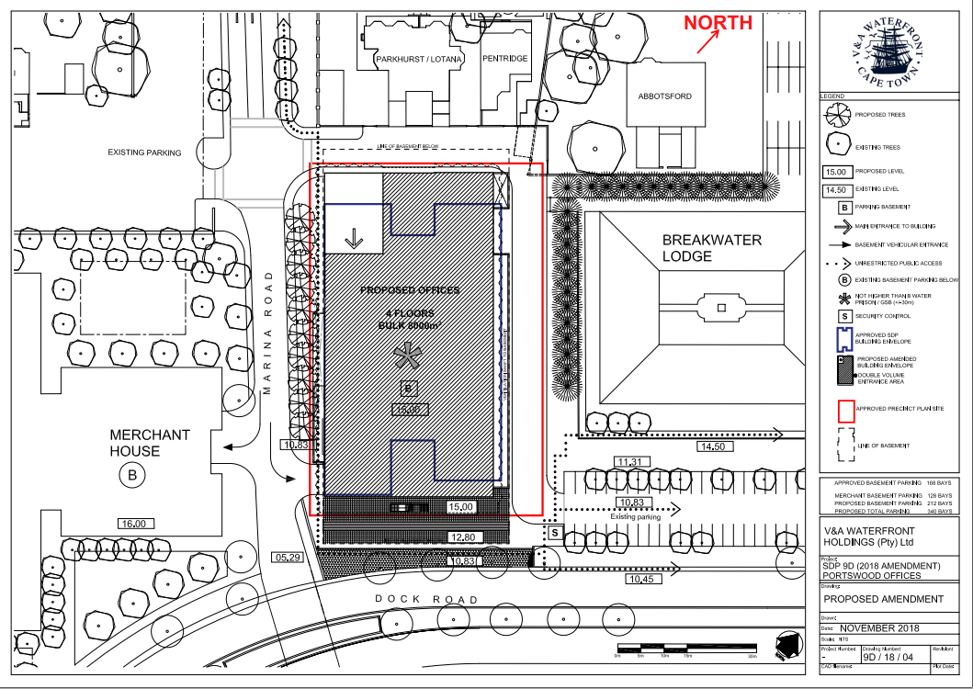.
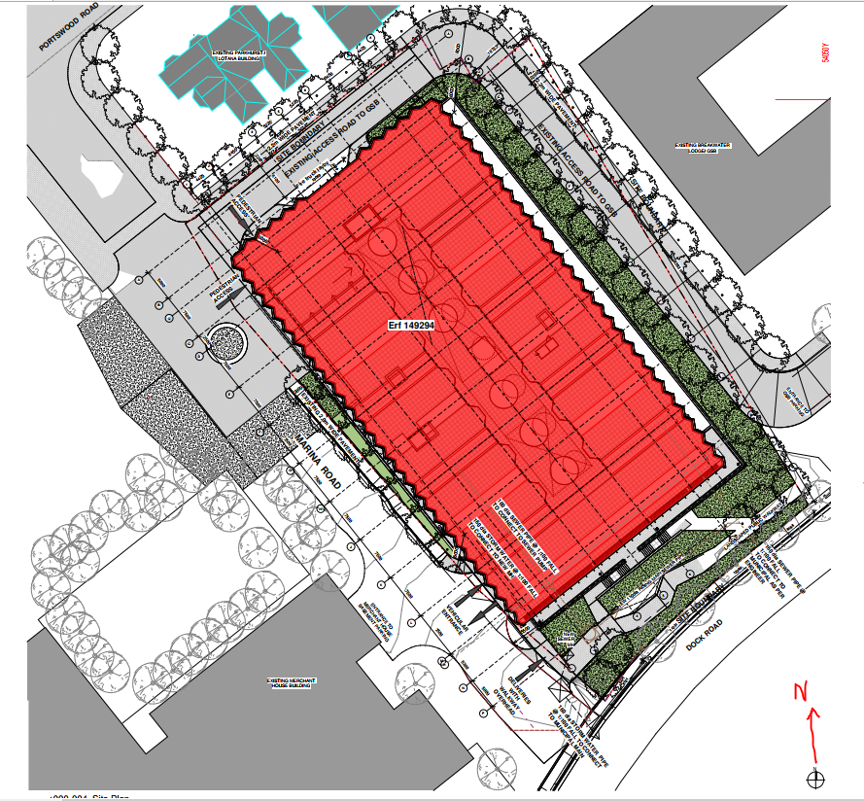

<Photo – showing the sides of the façade facing North>

- The timber façade also forms part of a range of measures facilitating natural indoor temperature control and fresh air inside the building, instead of conventional air conditioning (HVAC), during most of the year.

This yields not only savings in operating costs for heating and cooling, but also greatly benefits health, productivity and worker well-being for building users. This significantly reduces the operating carbon emissions of the new building.

- That the use of a natural material in place of aluminium, glass, brick and concrete in the façade has greatly reduced the Ridge’s carbon and energy footprint by reducing its embodied carbon as built. Structurally graded and FSC-certified engineered timber as used in the production of the CLT (timber) cladding is sourced from sustainable plantations which are largely located within the Western Cape. In addition to the material being a net sequestrator of carbon dioxide from the atmosphere, timber sourced within the province minimises the transport carbon and energy considerations also”, (see interview with the manufacturer below), explains the Development Director at the V&A Waterfront, Mark Noble.

The engineering consultants on the project, ARUP, have calculated that 354 Mt of CO₂ has been saved by using timber on this project in lieu of conventional materials (e.g. brickwork) in addition to the usage of a natural material which itself enters the lifecycle of the project with a negative embodied carbon content.

Explainer:

The principle of embodied carbon comes from assessing the amount of energy consumed and carbon dioxide released into the atmosphere by the mining and production of many common building materials from cradle (source, including mining activity) to gate (completed product leaving the factory) plus the fossil fuel burned to produce that material and its transportation.

The table below lists the embodied carbon content for various common building materials.
Engineered timber carries a very low embodied carbon (and energy) content because of its natural source and relatively low energy used during its manufacture.

Material | Embodied carbon (cradle to gate) kg CO2e equivalent/kg | Carbon sequestration in MT/m3 of the raw material | Density  kg/m3 | Carbon sequestered in MT COe/kg of material | Net reduction or (-) increase in GHG production
Aluminium | 9.1 | 0 | N/A | Zero | +9.1
Toughened glass | 1.35 | 0 | N/A | Zero | +1.35
CLT timber* | 0.87 | 0.8Mt / m3 | 480 | 1.67 kg COe/kg | -0.8

* References: Integrated Carbon and Energy Guide - Bath University / BSRIA

As can be seen, not only does the CLT timber have a lower embodied carbon content, due to its processing and transport considerations, it also is a net reducer of carbon from the atmosphere (carbon sequestered - trees convert CO2 to O2). The Ridge uses 36 MT (36 000 kg) of CLT. Therefore, the use of CLT timber at the Ridge has sequestered (removed) 60 MT of carbon dioxide equivalent from the atmosphere since the original plantations were planted. For comparison purposes, this is equivalent to the total production of GHG of 13 average saloon cars per year.

Impact of sustainable forestry
“Provided at the timber is sourced from a sustainable forest that replants trees at the same rate at which they are removed, and the timber which is then used in construction does not decompose or is burnt; then arguably carbon sequestration is taking place in the short-term cycle and can be accounted for” - BSRIA/Bath University ICE Guide.

Hence, in summary, the Ridge features a double carbon saving by adopting CLT timber façade construction and this makes the method well worth promoting in an age of climate change. First, by choosing CLT GHG (as COe) emissions from concrete, steel and aluminum are avoided, all of which have high carbon footprints. And second, the CLT stores carbon dioxide that was absorbed when the tree was growing, and locks it away for as long as that building stands.

Biophilic design
Biophilic design is a concept used within the building industry to increase occupant connectivity to the natural environment through the use of direct nature, indirect nature, and space and place conditions. Experts argue that this concept has health, environmental, and economic benefits for building occupants and urban environments (Ref: https://en.wikipedia.org/wiki/Biophilic_design ).

“Increasingly, the negative effects of building in the ‘business as usual’ way for people working in a conventional office building are being identified, worldwide. With our existing successful rollouts of people-centric designs in the Silo District and Merchant House, we wanted to raise the bar further by providing a working model that could be adapted and applied elsewhere. At the same time, we are meeting the sustainability aspirations of our client, Deloitte”, explains the Development Director at the V&A Waterfront, Mark Noble.

One of the negative results of traditional commercial building design in the past has been sick building syndrome (SBS.). The problems are more than philosophical. They are real and measurable. SBS explains the various illnesses among workers, absenteeism and poor morale among staff leading to a loss in productivity.

“Many credible studies in recent times have shown what increases in productivity can be achieved by adjusting the working environment closer to nature, boosting the company bottom line. This concept was not new to them and they accepted our design proposal.

“Effectively, we have proposed a new normal - Our Normal - with the new V&A Waterfront building, the Ridge”, says Noble.

Interview with the Project Architect

Lead architect on the Ridge, Sean Mahoney of Studio MAS Architecture and Urban Design, comments that structurally graded engineered timber is the most natural choice for walling on a sustainability building where the V&A Waterfront aims to utilise biophilic design principles.

“Ideas for a new eco building at the Portswood District of the V&A Waterfront began in 2014 with limited aesthetic guidelines, but a strong desire to create a green building that supported biodiversity and promoted biophilic design for the benefit of its occupants”, he explains.

Mahoney says that a multi-disciplinary team consisting of the V&A development team, Studio MAS and engineering consulting firm Arup, workshopped a sustainable design that was acceptable to the prospective client/tenant.

“Based on the obvious sustainability success of Merchant House (former HQ of BP South Africa), next to which the Ridge is located, as well as recent experiences in the Silo District, the developers wanted something that would build on those timeless green attributes and raise the bar even further into the realm of natural ventilation and people-centricity.

“It seems very obvious, but one of the key questions was: ‘On a good day, can the occupant open a window?’. Designing around a suitable response to this question in order to set the building apart from the sealed glassed-in prevailing corporate standard, would take our team on a 3-year path defining the Waterfront’s new normal standard. It also presents something fresh and unique”, he adds.

Mahoney says that ultimately, the value proposition put to the client, who required maximum bulk on site, would be based on:

- Natural ventilation including opening windows, providing climate control most of the year around instead switching on of air conditioning (HVAC), hence engaging occupants with the outside environment.
- Reduced running costs, due to the natural ventilation/hybrid design model that is in use.
- Keeping material use as locally-sourced as possible.
- Maximising the use of pre-manufactured elements

But why, the choice of timber? Mahoney says that a major design element hinged on the building having an operable façade. This is achieved via the unique zig-zag (pleated) façade concept, consisting of cross-laminated timber panels on one facet with high-performance glass set into aluminium on the other side. Most of the glassed units contain custom-designed opening windows.

“In Europe and on other continents, timber construction in the commercial space has become established fairly recently. In South Africa, however, where it is novel, we are setting a whole new standard in this area. Timber, along with other sustainability features enabled us to achieve various objectives, notably the ability of workers inside the building having a degree of control over their environment/air quality.

Working models and origami
Mahoney admits that inspiration for the pleated façade came in part from doing origami at his desk in the office. “Triangles as per origami shapes take on a special meaning in this building, as born out by the façade design and several other design elements. But ultimately the pleated façade is driven by logic: it creates a north-south- east-west orientation for the façade, meaning that you can control the effect of direct sunlight.

“Working hand in hand with the engineers, Arup, we took this concept to its ultimate conclusion - a surface made from a natural material which is predominately local, sustainable, and a room temperature material. It is as green as you can get under the design parameters.

“Timelessness in architecture is something that many designers strive for. This timber façade will evolve and keep functioning over the years, changing colour as it weathers, developing a patina, and making the building stand out as unique”.

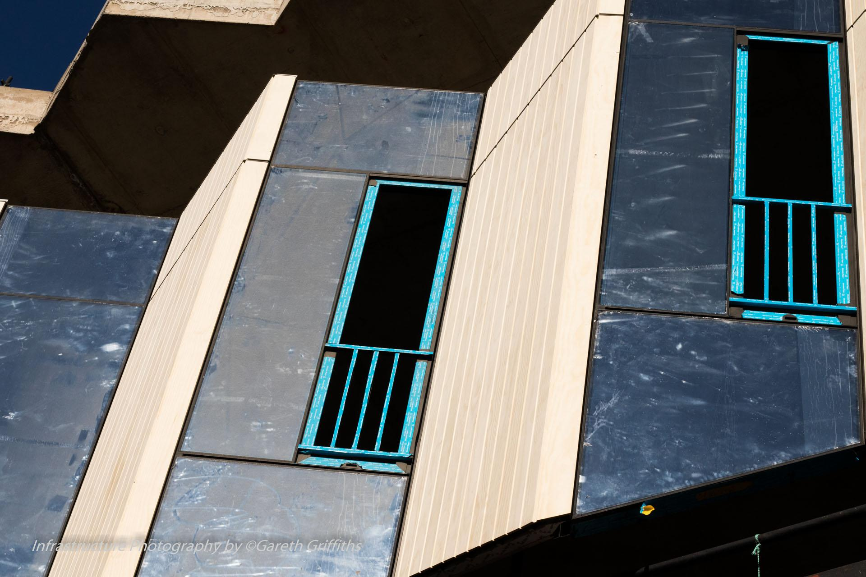

Interview with Project Engineer Lead

Tessa Brunette, lead engineering and façade consultant, Arup says: “The use of CLT is a large contributor to the green credentials of this building.

“It is also vital to make sure that the timber is as durable as conventional cladding materials. This has been done by adding a rain screen of timber cladding outside the CLT structural panels, which are not in themselves weatherproof and are protected by a breathable membrane. The rainscreen consists of Accoya, a type of board that is made from acetylated SA Pine cuts, which have a long service life and are guaranteed by the supplier. They can also be replaced separately, leaving the building still enclosed by the CLT panels so that occupation is not disrupted.

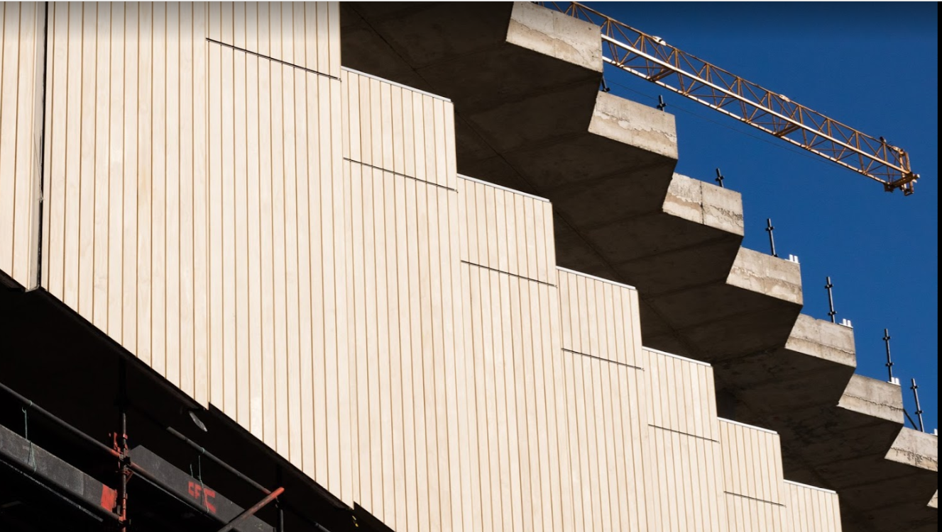

“The glazed and timber sawtooth façade is prefabricated to enable a swift installation time and ensure a high quality assembly. Using timber as a key component of the façade allows for the strong but light properties of this material to be taken advantage of in an innovative way, further strengthening the landmark nature of this building as a prestigious corporate headquarters. Timber is ideal for prefabrication because it can be machined to very high tolerances”, she adds

Considerable engineering modelling preceded the final design of the zig-zag façade and other options relating to different glazing types, orientations and shading types.

“Using the initial parametric modelling, we were able to identify a more refined set of options to assess which combinations worked best. It was found that the zigzag façade that we adopted for level 2 and 3 performs as well as a straight deeply shaded façade. In essence, orientating the glazing towards the north and south allows for a more glazed façade without external shading devices that can obstruct views to the outside and reduce the amount of internal natural light. This design significantly reduces the amount of sunlight entering the building, which in turn means that the internal spaces can largely rely on natural ventilation and not air conditioning to remain comfortable.”

“Together with the buildings’ intrinsic thermal mass, the façade itself is the most important ‘machine’ in the building,” Brunette concludes

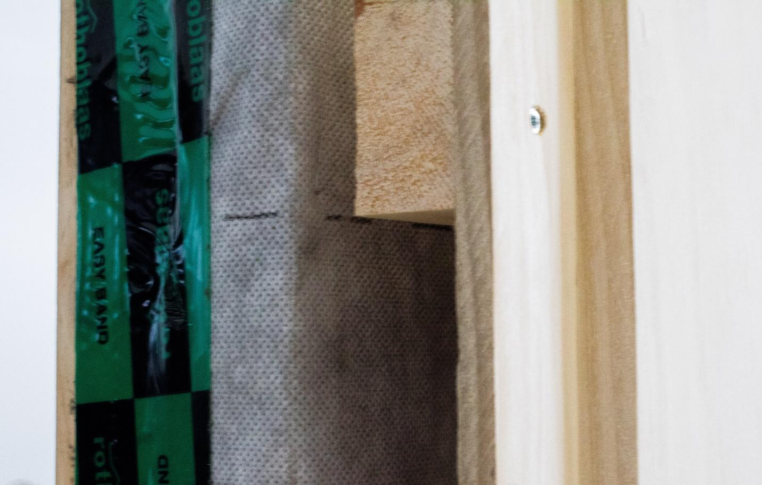

What is CLT?
Cross-laminated timber (CLT) is classified as an engineered timber, made into panels and used in construction of houses and commercial buildings. It is manufactured to specifications issued by the relevant authorities.

First developed and used in Germany, CLT is regarded as a fast rising star in the use of natural materials in construction.

Consisting of a structurally-graded ply with the timber ply running at ninety degree directions along each layer, the design provides structural strength in both linear directions, as opposed to conventional laminated timber (glulam) where the strength lies in one direction only - the direction of the grain.

The usage of CLT in Europe grew from the early 1990s and the first national specifications were issued by Austrian authorities in 2002. Usages included housing and for multi-storey buildings. As recently as 2015, the USA National Building Code incorporated CLT, followed by the International Building Code.

CLT is made by gluing together layers of solid-sawn lumber. Each layer of boards is usually oriented perpendicular to adjacent layers and glued on the wide faces of each board, usually in a symmetric way so that the outer layers have the same orientation. An odd number of layers (3,5,7, etc) is most common, although even number configurations do exist. Regular timber is an anisotropic material, meaning that the physical properties change depending on the direction at which the force is applied. By gluing layers of timber at right angles, the panel is able to achieve better structural rigidity in both directions. It is similar to plytimber but with distinctively thicker laminations (Ref: https://en.wikipedia.org/wiki/Cross-laminated_timber )

Termed mass timber construction, numerous buildings internationally have been made from this timber, although it is still regarded as a rarity in SA.

CLT at the Ridge: Interview with the manufacturer.
At the Ridge, 960 m² of CLT timber panels were used to clad the building, equivalent to 36 tonnes of timber. The CTL timber panels were fabricated at a dedicated factory in Cape Town.
According to Jamie Smily of XLAM in Retreat, the SA Bureau of Standards has developed a SANS standard for cross-laminated timber, meaning that the product is now recognised as a standard building material in South Africa. At present, the only timber factory making the material is the factory in Retreat.
“We are an FSC-certified (Forest Stewardship Council) manufacturer. Our timber is sourced from sustainable plantations, mainly in the Western Cape. We receive it as rough-cut boards from the timber mills. The boards are the pressure impregnated to treat the timber and then dried it to the correct moisture content.
“The dried product is then finger-jointed and planed on all four sides. Planed panels are then laid up in the press with adhesive applied between the layers, then vacuum pressed into the desired panels. Each CLT panel consists of an odd number of individual layers, which are then finished by sanding and cutting. The product is structurally-graded and manufactured to a much larger format than, say, shutter ply, although the principles of manufacture are similar.”
In line with the sustainability focus of the Ridge project, the CLT timber used in the façade is bonded in the factory using a low volatile organic compound resin made from polyurethane.
“The final product as installed on site is long-lasting with a service life of 50 years plus. In addition to the rainscreen covering on the facade, the adhesive used in making the CLT is waterproof, which is ideal for the Cape winter.
“Our factory has a number of projects on the go in both residential and commercial spaces and this signals well for CLT, which is taking off very well”, he concludes.

Interview with the Façade Fabricator and Erector
Ter de Villiers is the Project Manager for Geustyn & Horak in Bloemfontein on the Ridge Project. According to De Villiers: “A G&H team is based on-site in Cape Town under the supervision of Eugene Markram, who has a the very challenging task of bringing everything together by delivering an end product that reflects a high standard of quality, on time. With all the variables at play in the industry, it’s not an easy task.
“The Ridge façade project is different because the façade is a combination of aluminium and timber. The interface between the two materials posed quite a few challenges, but I think the end product is something unique.”

CLT is increasingly being used for tall buildings globally.
- Opened in mid-March 2019, the Mjøstårnet/ Mjøsa Tower in Brumunddal near Oslo, Norway, reaching 85.4 metres, is currently the world’s tallest timber building. The 18-storey tower is made from lightweight prefabricated materials, consisting of glulam, CLT and laminated veneer timber.

- Brock Commons Tallwood House is an 18-storey student residence at the Point Grey Campus of the University of British Columbia in Canada. At the time it was opened, it was the tallest mass timber structure in the world.

- Another famous structural timber-containing commercial building under construction is the Google London Headquarters at King’s Cross. With a huge surface ‘footprint’ on the ground, and referred to as a “Landscraper” offering 92 000 m2 of interior space. At 300m long, it is longer than the “Shard”, currently London’s tallest building, is high and timber is extensively featured, including the façade. This building is designed by the firm of Thomas Heatherwick CBE (Heatherwick Studios), who incidentally was the visionary architect behind the redevelopment of the V&A Grain Silo into the Zeitz MOCAA Museum of Art and SILO Hotel. (rendering by Heatherwick Studios)

Image below: Courtesy Heatherwick Studios. The Google Kings Cross HQ.
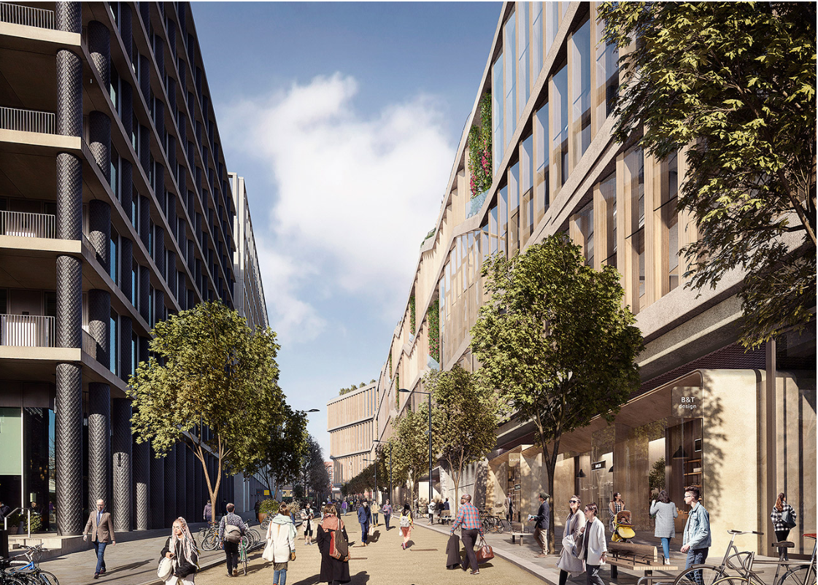

CLT Timber Fast Facts

- CLT stands for cross laminated timber. Whilst it is similar to Glulam, or “shutter-board”, the timber grain runs in perpendicular directions in each layer, imparting great cross-direction strength to the product.
- CLT has become increasingly popular in Europe, the USA and Canada. Building codes and specifications have been issued governing its use. It offers unique benefits to the environmental performance of the building by way of lowering the building’s contribution to greenhouse gas emission.
- CLT has a very long lifespan. Used at the Ridge, it is designed to last as long as the building.
- At the Ridge, the CLT panels installed feature a sacrificial layer of timber skin on the outside as a rainscreen, which will weather and produce beautiful colours over its lifecycle. It can theoretically be replaced, although it is unlikely that this will be necessary. <see photo>
- CLT is a warm and people-friendly material. Inhabitants of the building will benefit by working in an office that features a low emission and low human toxicity material. Where is is applied, the CLT façade forms part of the inner wall of the building as well, Meaning that office workers will enjoy the low emissivity and warm glow of natural timber inside their workspace also.

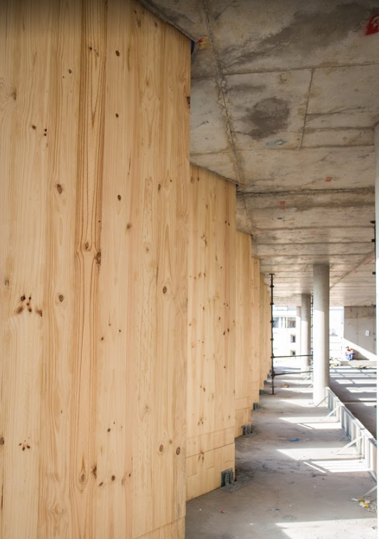

- The Ridge is one of the first commercial buildings in South Africa to feature a timber exterior and interior cladding.

Façade design, manufacture and installation team
Developer: V&A Waterfront
Architect: Studio MAS
Engineering/Consultants: ARUP
CLT fabricator: XLAM
Façade – Aluminium & Glass Fabricator and Erector: Geustyn & Horak

Authored by: Gareth Griffiths - 082 784 5616

